**ABSTRACT**

*Online placement system has very important role in college, its aims at providing the help to automate and simplify the registration process.*

*Initially all the process of the Placement Cell was done manually like collecting student data, storing it in spreadsheets, storing company’s information and criteria, selecting eligible students, acknowledging the students and generating reports, therefore we intend to introduce a system which is capable of performing tasks which will reduce the effort of the Placement Cell Coordinators to a huge extent.*

*The Website will have the records (personal details, academic details) of all the students who wish to appear for the placement in the current academic year. The Coordinator can generate a list of eligible students as soon as the application form by the students is filled and submitted. The students are selected on the basis of the company criteria.*

*The companies can be added/viewed by the coordinator. The students will receive the mail if they are eligible for a particular company. Then the students need to login to their account for confirmation and view the details of the company. The coordinator then generates the final list of interested students. If a student is selected in a particular round, then the student is promoted by the coordinator for further rounds.*

*At the end reports are generated for a company, the number of eligible, interested, hired candidates. From the reports the coordinator will come to know about the weak points of students and where the students are lacking and hence the college can come up with different placement activities which will help the students in improving their skillsets. One of the biggest challenges that higher learning institutions face today is to improve the placement performance of students.*

CHAPTER 1

**INTRODUCTION**

The manual work makes the process slow and other problems such as inconsistency and ambiguity on operations. The increasing advantages of an automated system now are at highest position thus many manual processes are automated. Since the automated systems are demanded, educational infrastructures like colleges needed their manual systems to function on computer system. One of such system which is of major importance is placement automation for campus recruitment. This project is aimed at developing a web application for the Placement Department of the college. This system can be used as an application for the Placement Coordinator of the college to manage the student information with regards to placement. Students logging should be able to upload their information in the form of a resume. So, all the information will store the details of the students including their educational qualification, personal details, university marks and their resume’s drive link. This system helps Coordinator to access the student information with regards to placement. Coordinator can notify the students about the eligibility for a company via sending an e-mail. This system can be used as an application for college to manage the student records according placement.

CHAPTER 2

**LITERATURE SURVEY**

1. **https://placement.daiict.ac.in/**

The administration of Training and Placement is bolstered by paper-based frameworks, databases,

spreadsheets and E-mail interchanges. Preparing and Placement is the urgent part of any instructive

establishment in which a large portion of the work till now is being done physically.

1. **https://ieeexplore.ieee.org/document/8014632/authors**

The primary aim of students who join professional courses in higher learning institutions is to secure a

well-paid job In a reputed organization. Professional education can be either completely technical or it

can be managerial as well Bachelors of Technology (B Tech) provides technical education to students

in various fields such as Computer Science and Engineering

1. **http://ijarcsse.com/Before_August_2017/docs/papers/Volume_7/4_April2017/V7I3-0181.pdf**

This system gives the very efficient way of placement of students. In this system the student does their registration very simple manner the placement officer can easily get the information of students. The system gets easy access to the eligible student.

1. **https://www.irjet.net/archives/V3/i4/IRJET-V3I4607.pdf**

Online Training and Placement system automates activities of Training and placement cell and place the best coordination between student. It provide student community to use collective intelligence to increase selection ratio and eases out process of creation of management information automatically.

CHAPTER 3

**DESIGN**

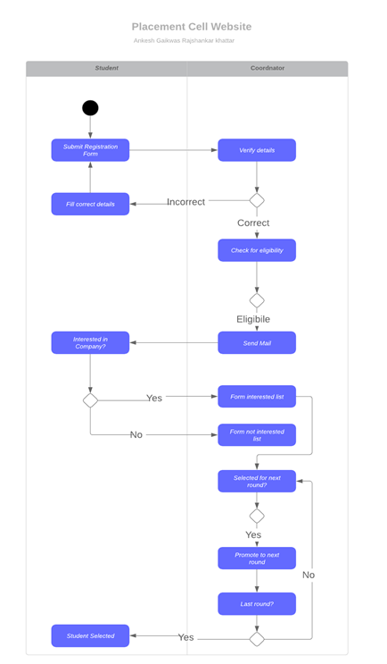

**Figure:** Swimlane activity diagram

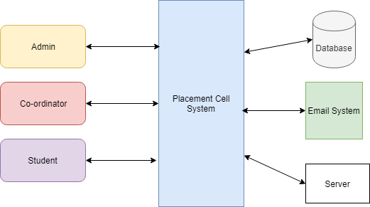

**Figure:** Block Diagram

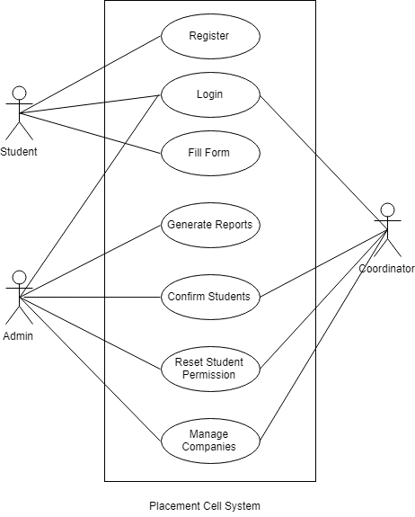

**Figure:** Use case diagram

CHAPTER 4

**IMPLEMENTATION**

* **Creation of Users:**

Firstly, the coordinator creates login for students for the current academic year for their respective department. Once the logins are created the students can login with the help of their Roll Number(unique) and a default password.

* **Registration form**

After this, the student fills in her/his personal details, academic details and KT details and submits the registration form.

These details are recorded by the system into the database.

* **Verifying details:**

The filled details by the students are verified the coordinators. If the details are correct then the student is accepted for further placement activities. If the student has not filled in correct data then the student is acknowledged about the same and changes are made accordingly.

* **Resetting students:**

Once the results for a particular semester are declared, the student’s registration from is reset to update the marks of that semester. The details already verified by the coordinator cannot be modified.

* **Adding Company:**

The companies which approach the campus recruitment are added. The company details, company criteria, round information are recorded.

* **Interested:**

The eligible students then, can either apply for the company or can opt out of the process.

Based on the response of the student, an interested list of students is maintained and also a list of not interested students is made.

* **Promoting rounds/Selected**

If the student has cleared a particular round of the company then she/he is promoted to the next round and finally into the selected students list.

* **Other features:**
  + Logs

Each activity of the student or the coordinator is monitored with the help of maintaining logs. A log is created for logging in, logging out, update profile, change password, confirmation by coordinator, updating of profile by coordinator.

* + Hashed Passwords

The passwords are hashed in the database. If the user forgets the password then the user can click on forgot password link and an email will be sent to change the password.

* + Deletion of user logins

After the placement activities for the current academic year is finished the coordinator can delete the logins of the users thereby restricting access to them.

* + Security features

The website is free from security breaches like SQL Injection. The inputted data is server side validated for correctness. User authentication is done with the help of hashed passwords.

**Technology Stack:**

1. PHP

We used PHP version 5 for backend development of our project.

1. HTML

We used HTML for the front-end development of the project.

1. MySQL

MySQL Server was used for the Database.

1. PHPMailer

PHPMailer was used to send mails.

**Implementation:**

* Admin

The Admin’s role is generating reports at the end of the placement process for the current academic year. The Admin analyses the placement records and based on these comes up with conclusions, where the students are lacking and what needs to be worked upon to increase the placed percentage of the students in the next year.

The Admin interacts with the system to view reports, data, graphs and other statistical records to come up with strong conclusions.

* Coordinator

The Coordinator verifies the details provided by the students and updates the information if required. After results of every semester the coordinator resets the registration form of student so that they can enter their recent university examination details.

The list of eligible students is generated by the system. The coordinator sends mail to the eligible students. If a studenta is already selected for a regular company then she/he is not eligible for another regular company (unless specified by the placement cell). Moreover, if a student is selected in a regular company then she/he is eligible for placement activities of a dream company.

As the students clears the rounds of the company, the student is promoted to next round by the coordinator. Hence a list is maintained by coordinator in which the students who have cleared which rounds is stored. A final list of selected students by the company is also maintained in which the coordinator enters the offer letter number and other details regarding the selection of the student.

* Student

The student needs to register by filling in personal details and academic details. The verification of the form is notified to the student in the home tab, whether the details of the form are verified or not by the coordinator. If the student eligible for a company then she/he receives a mail and a notification in the confirmation tab. The student can either accept or reject the opportunity.

CHAPTER 5

**SCREENSHOTS**

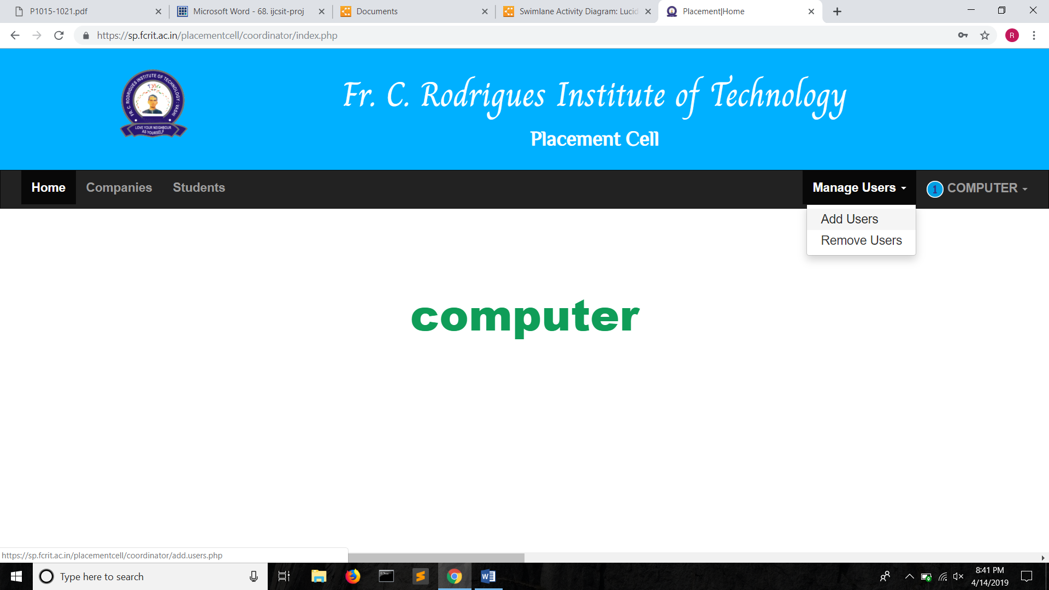

**Figure:** Creation of Users

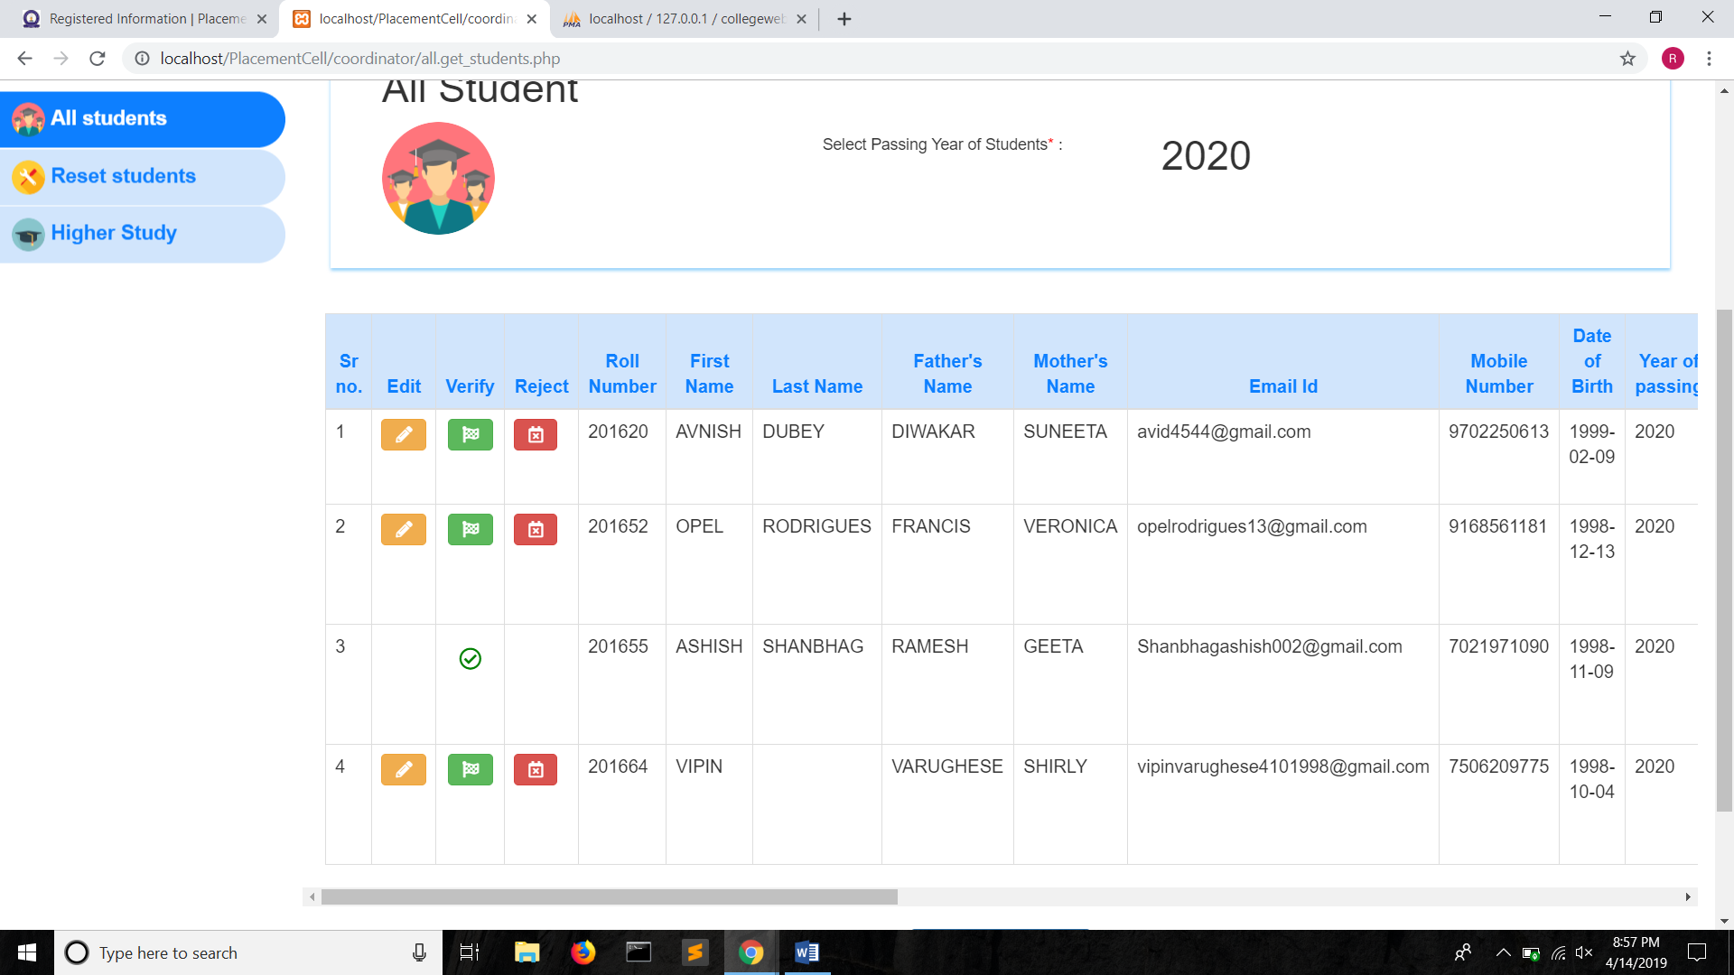

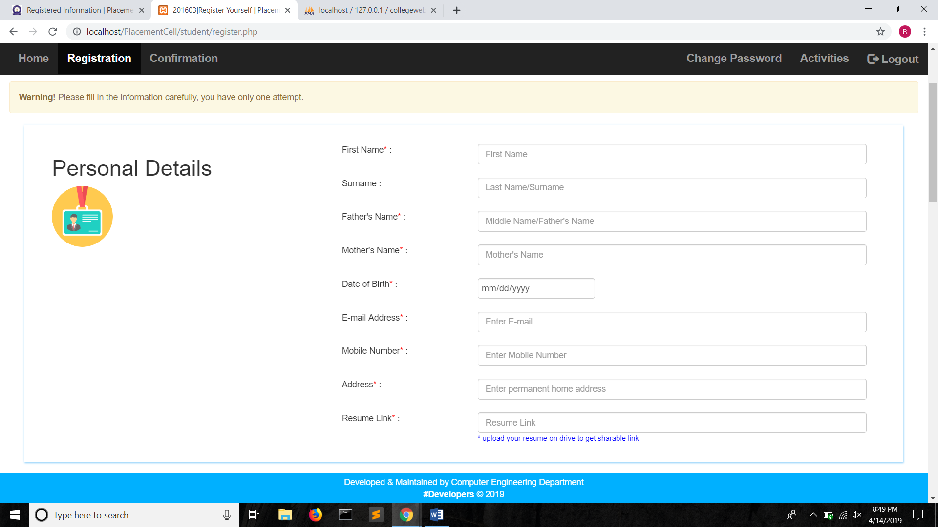

**Figure:** Registration form (1)

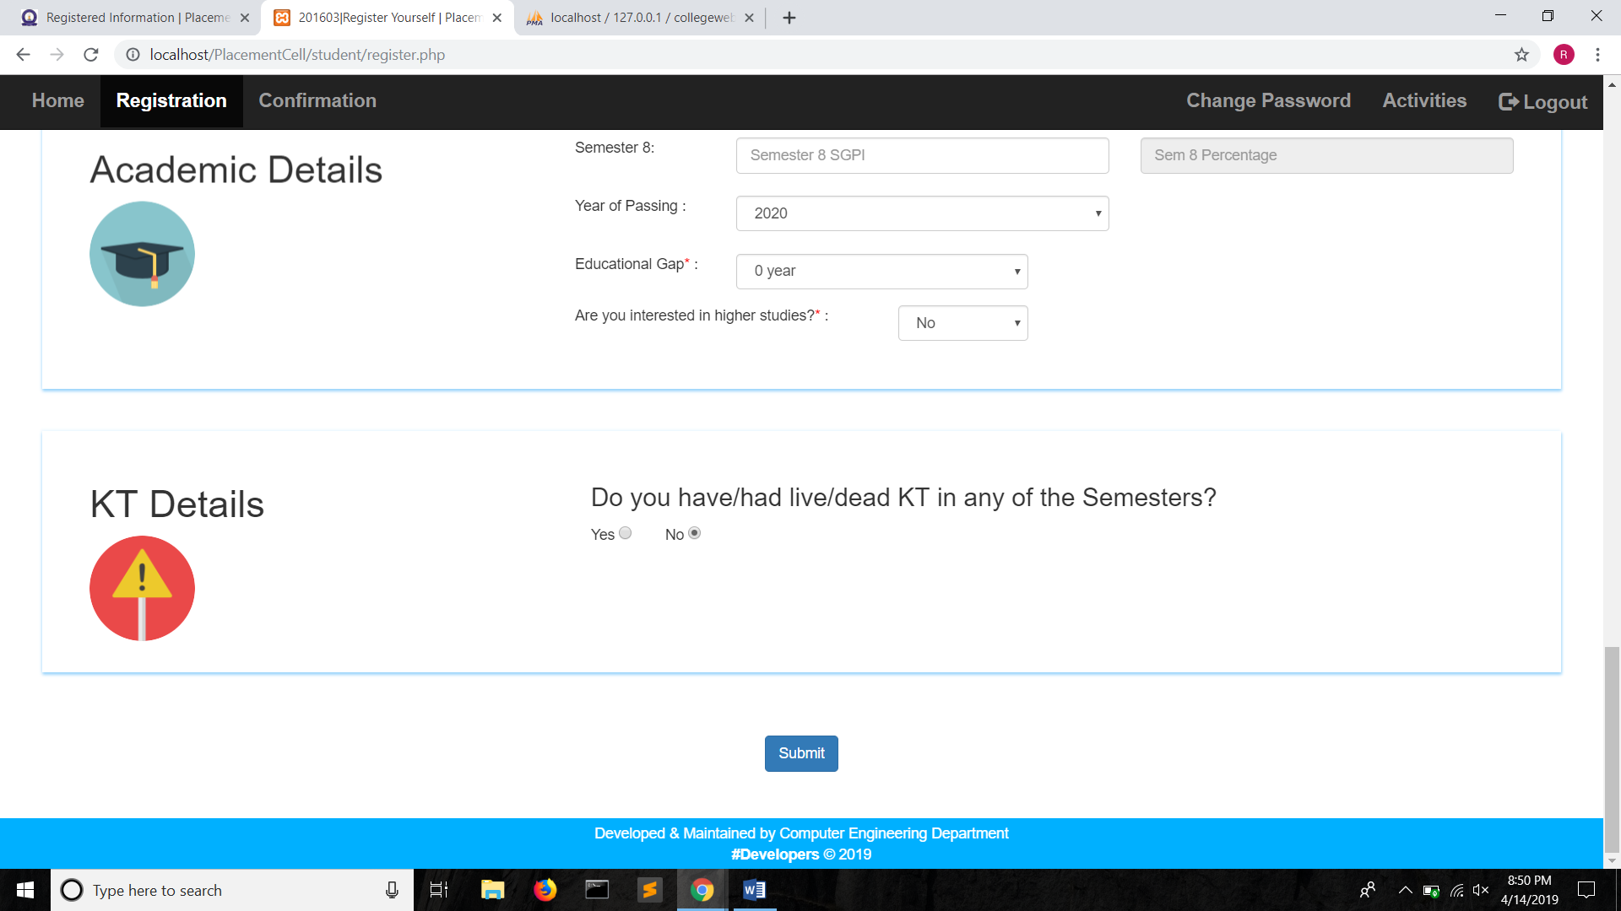

**Figure:** Registration from (2)

**Figure:** Verifying detai

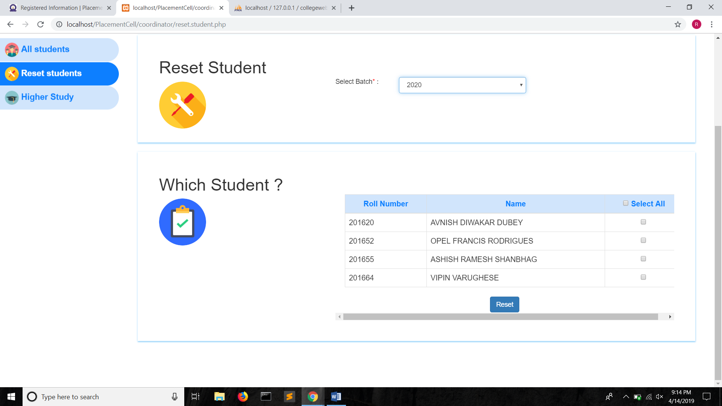

**Figure:** Reset student

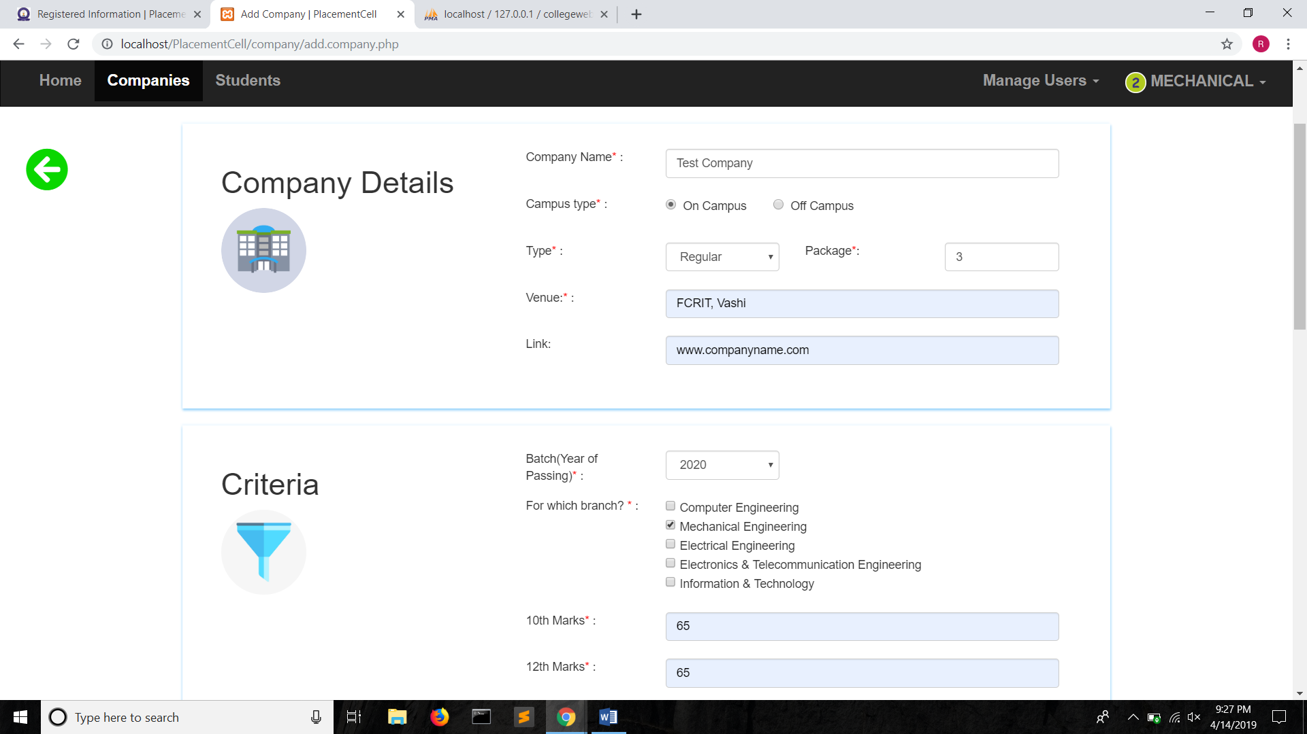

**Figure:** Adding company (1)

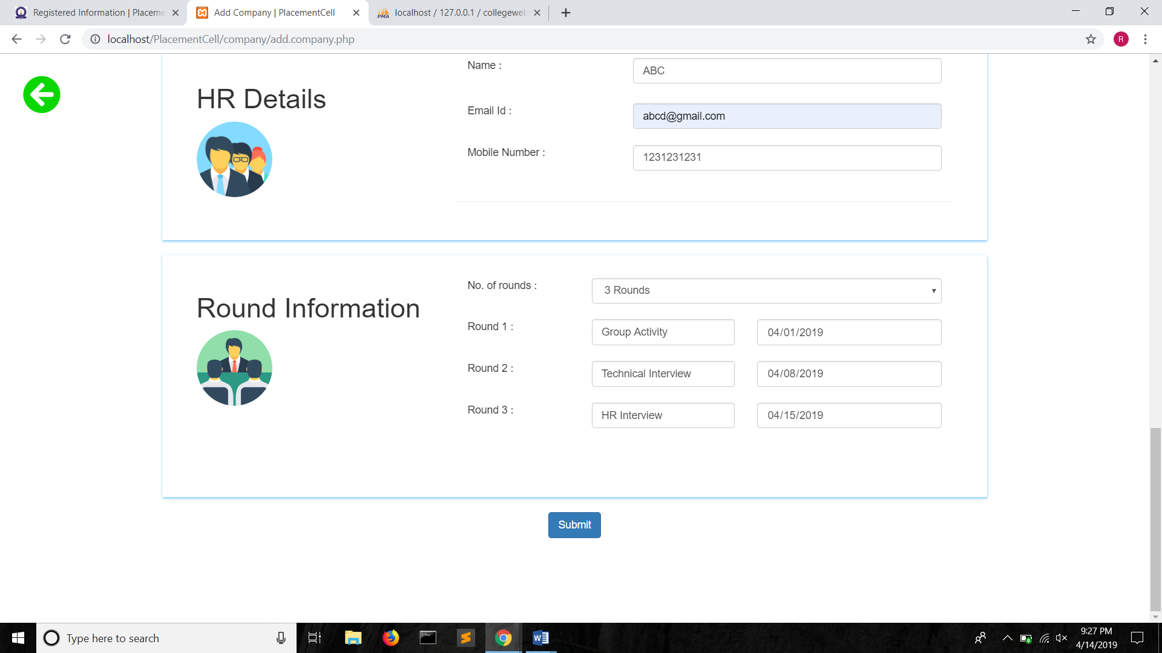

**Figure:** Adding company (2)

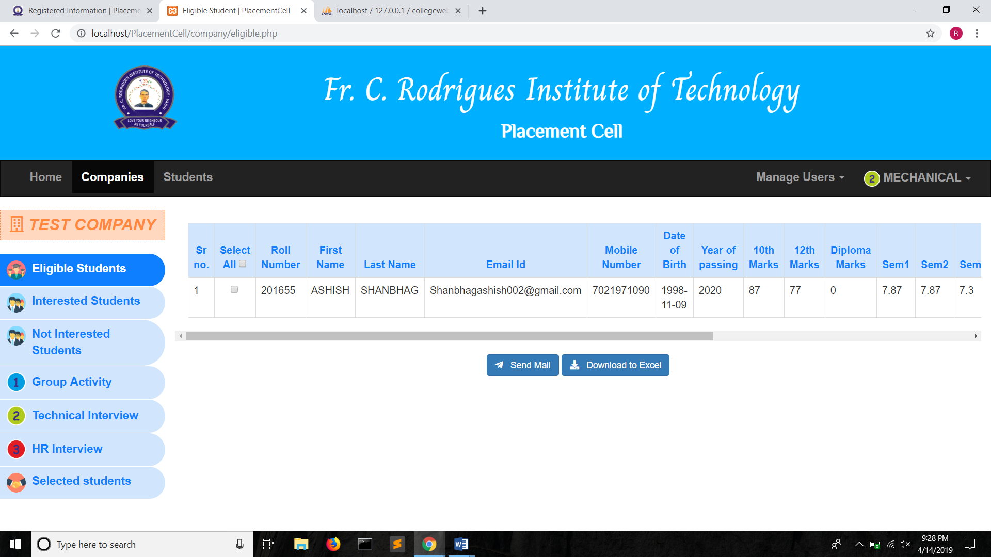

**Figure:** Eligible students

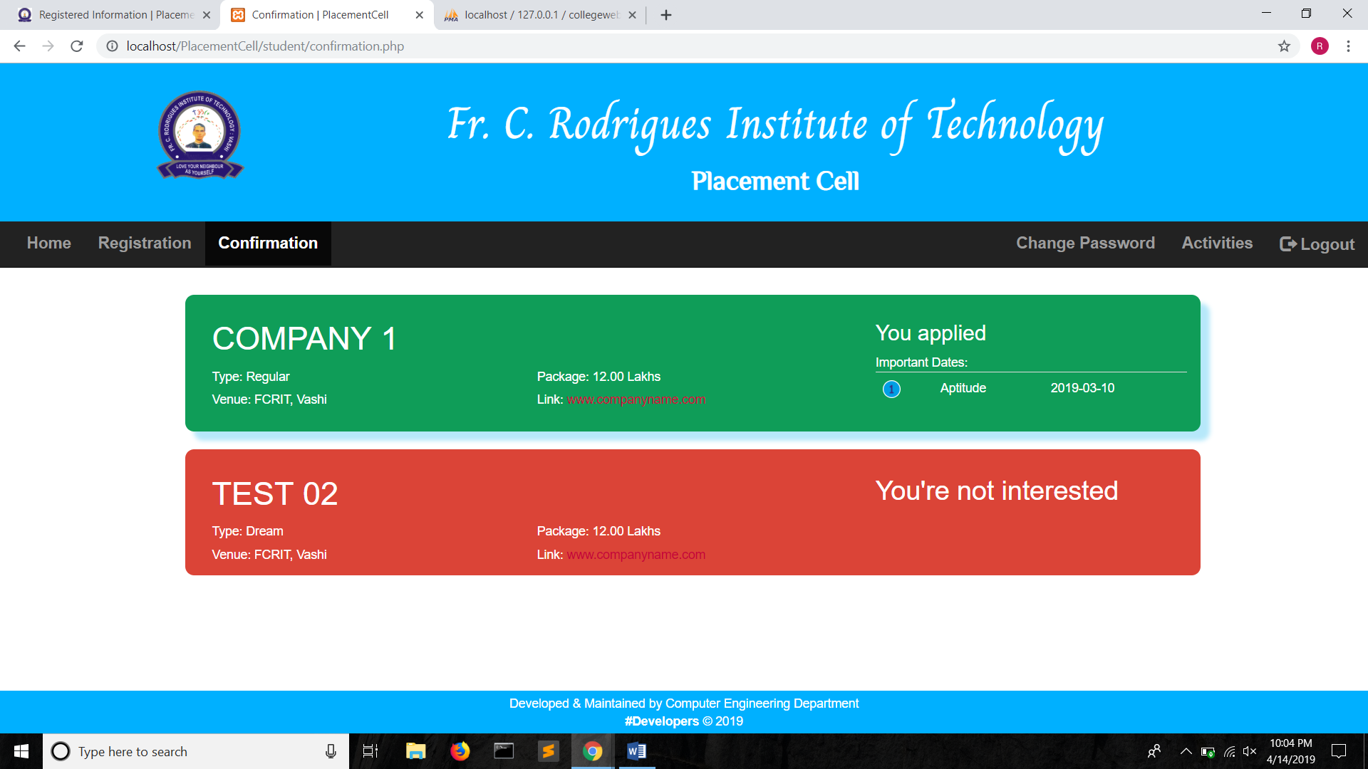

**Figure:** Confirmation

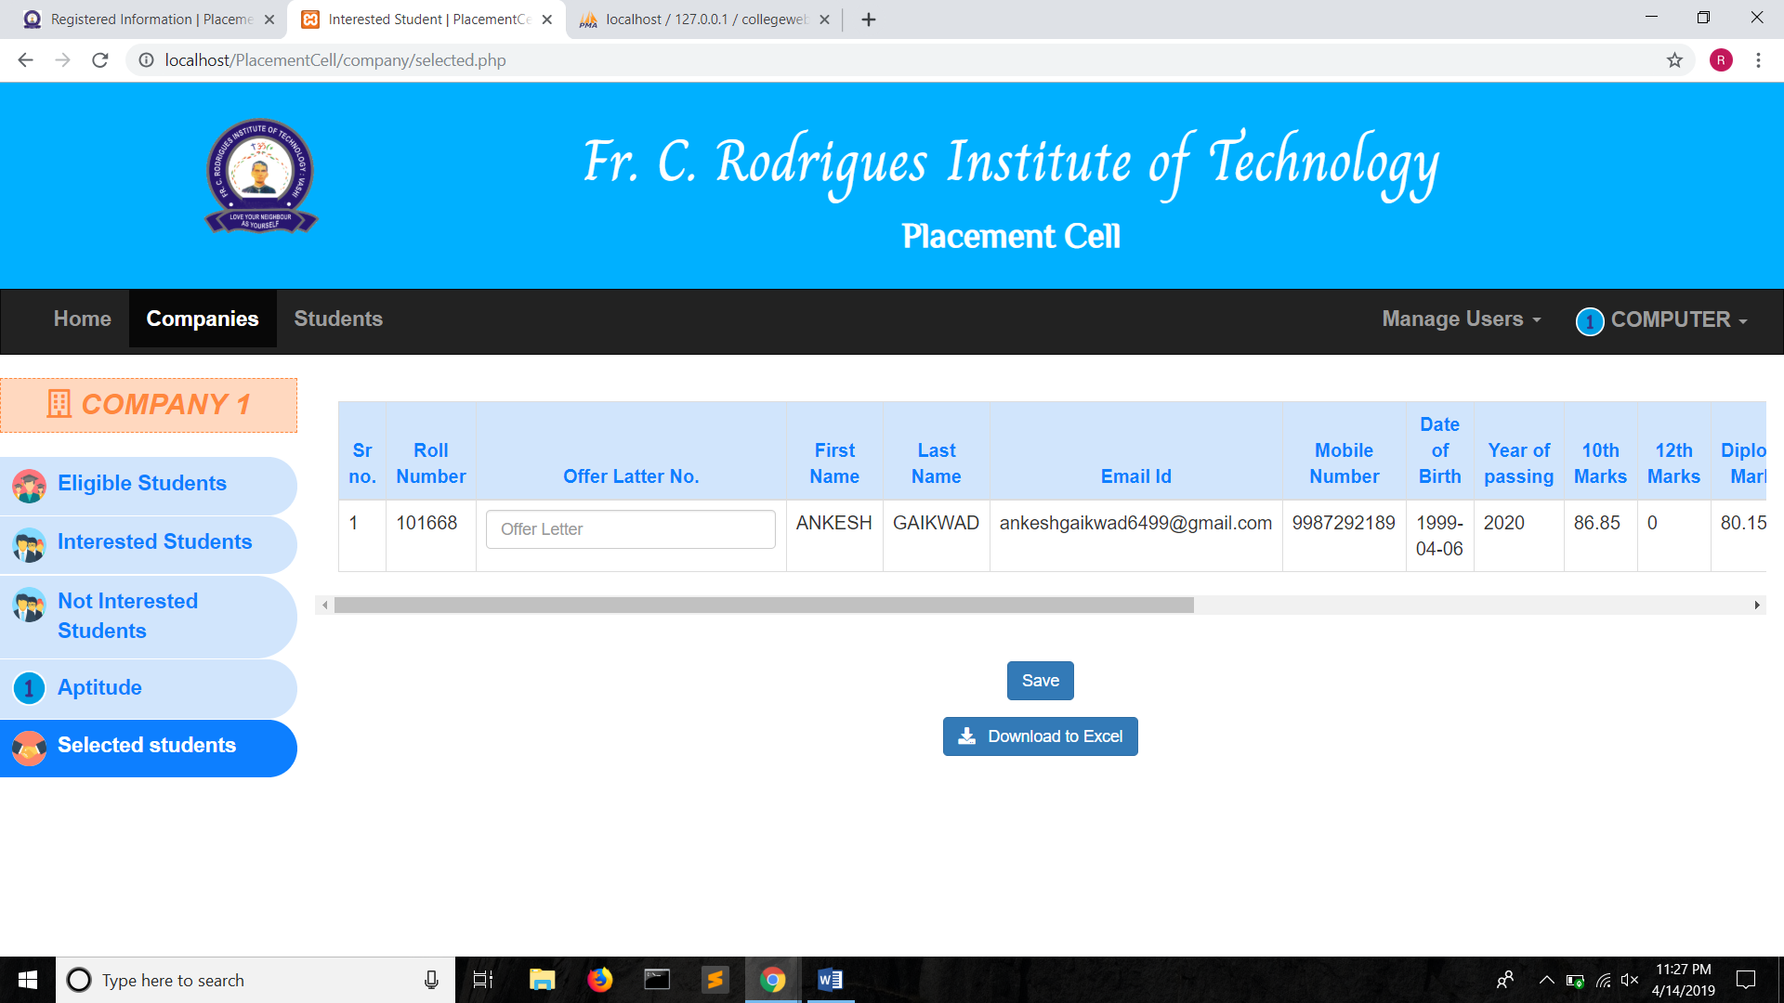

**Figure:** Selected students list

CHAPTER 6

**RESULT**

**CONCLUSION**

Our proposed system work according to IEEE paper. It can successfully login authorized person to system and register them. In our system admin can check the Student list those eligible according to criteria given by the Company and notify them instantly and update the information anytime successfully. Our system is Secure and User-friendly for all of three modules.

Before the system was introduced, the placement cell faced many issues like storing of data of students, acknowledging the students about the placement activities, selecting the eligible students and generating reports based on the number of students placed. This was very tedious and time-consuming job for the placement cell coordinators. But now, the system takes care of these issues.

The proposed system stores user information, activates/deactivates student logins and generates reports. The task of the coordinators to verify the details of the students and thus generate eligible students list is made easier with the help of the placement cell website.

The system is secure, reliable and user-friendly.

The software takes care of all the requirements of College student and is capable to provide easy and effective information related to student academic session and their score in exam. It generates reports that provide description details including various number of student placed in company. It also provides placed student information according to company

**Future Scope:**

Machine Learning algorithms can be applied on the generated data to analyze the patterns in the data and to determine the weak and strong points in the students and thus training them accordingly.

Online placement tests can be conducted on the system. Weekly aptitude tests or Group discussion on a blog can made possible in the system.

The back-up procedure can be incorporated to make sure of the database integrity.

**ACKNOWDEGEMENT**

**REFERENCES**

* http://www.placementhansraj.com
* http://placements.iitb.ac.in/
* http://www.universitycollege.ac.in/index.php/placementcell
* https://www.skplacementcell.in/
* https://placement.daiict.ac.in/